# Electronic Device Rating Prediction

Report

Team: CS_27

يوسف محمد سيد محمد 2021170642 sec 8

-----------------------------------------------------------------

محمد عوض طلعت محمد 2021170480 sec 6

-----------------------------------------------------------------

يوسف وجيه وديع ناشد 2021170654 sec 8

-----------------------------------------------------------------

يوسف مصطفى محمد يوسف 2021170649 sec 8

-----------------------------------------------------------------

محمد مبروك فكرى عبدالفتاح 2021170483 sec 6

-----------------------------------------------------------------

يوسف عمرو احمد زهران 2021170641 sec 8

# Bar Graphs

Training & Testing Accuracy

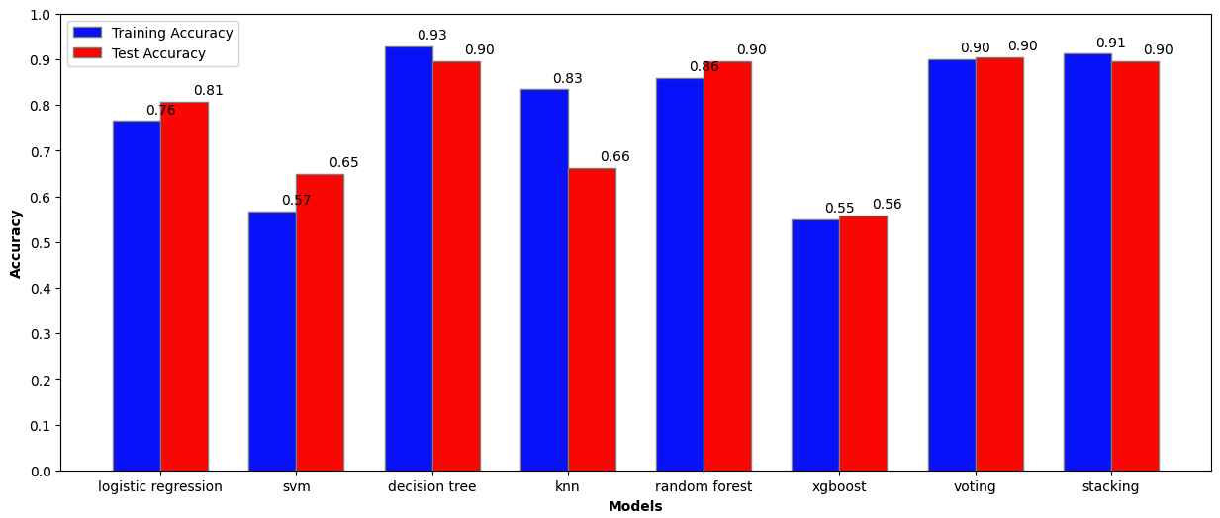

Testing Models Time   
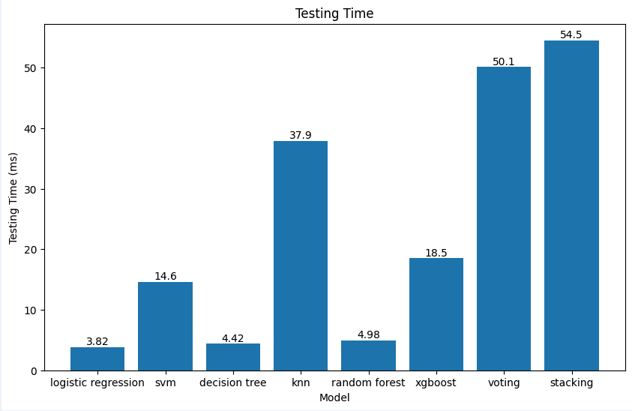

Training Models Time  
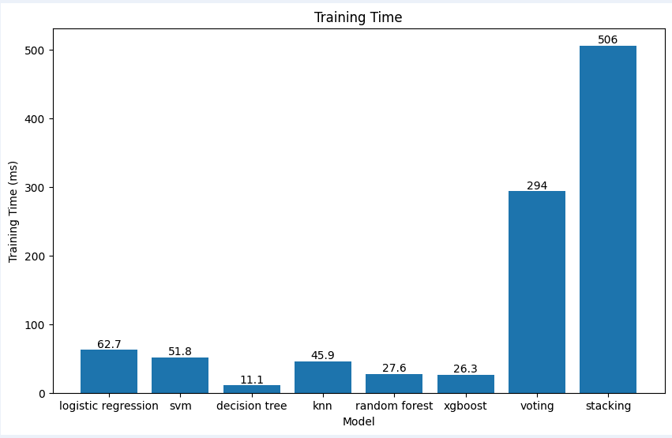

# Feature Selection

Chi-Squared  
since the input variables and output variables are categorical, Chi-Squared Feature Selection was the best choice and gave the highest accuracy when setting the K hyper parameter to 22

# Hyperparameter Tuning

Decision Tree

* when max_depth = 5 – the best  
  + Training MSE: 0.0726643598615917
  + Testing MSE: 0.10344827586206896
  + Training Accuracy: 0.9273356401384083
  + Testing Accuracy: 0.896551724137931
* when max_depth = 4   
  + Training MSE: 0.0847750865051903
  + Testing MSE: 0.1103448275862069
  + Training Accuracy: 0.9152249134948097
  + Testing Accuracy: 0.8896551724137931
* when max_depth = 10 – overfitting  
  + Training MSE: 0.0034602076124567475
  + Testing MSE: 0.10344827586206896
  + Training Accuracy: 0.9965397923875432
  + Testing Accuracy: 0.896551724137931

## KNN:

* when n_neighbors = 3– the best  
  + Training MSE: 0.16608996539792387
  + Testing MSE: 0.33793103448275863
  + Training Accuracy: 0.8339100346020761
  + Testing Accuracy: 0.6620689655172414
* when n_neighbors = 1 -- overfitting   
  + Training MSE: 0.0
  + Testing MSE: 0.27586206896551724
  + Training Accuracy: 1.0
  + Testing Accuracy: 0.7241379310344828
* when n_neighbors = 10  
  + Training MSE: 0.2975778546712803
  + Testing MSE: 0.46206896551724136
  + Training Accuracy: 0.7024221453287197
  + Testing Accuracy: 0.5379310344827586

Conclusion:

The project successfully classified electronic device ratings using machine learning models. Among the models tested, the Decision Tree achieved the highest accuracy with efficient training and testing times. The results were challenging because many of them were overfitting and cannot be considered. Overall, the project highlighted the importance of model selection and evaluation in classification tasks.